World Cheat Sheet – Echoes of Kaelithar

# Sornaria

## Description

The first major city and kingdom in the world of Kaelithar. Known for its welcoming culture and immense population diversity. Surrounded by vast fields, forests, bodies of water, and protected by large stone wall fortifications. Ideal starting hub for any adventuring party.

## Politics

Democratic monarchy hybrid. One elected governor rules most decisions while an old bloodline of royalty still holds a ceremonial role with some sway in politics.

## Population

Mixed population — all playable races live here in varying harmony.

## Main Exports

Food, livestock, agriculture, potions, beer, wine

## Narrative/Notes

Notable locations: The Gilded Tankard, central trade district, multiple guild halls.

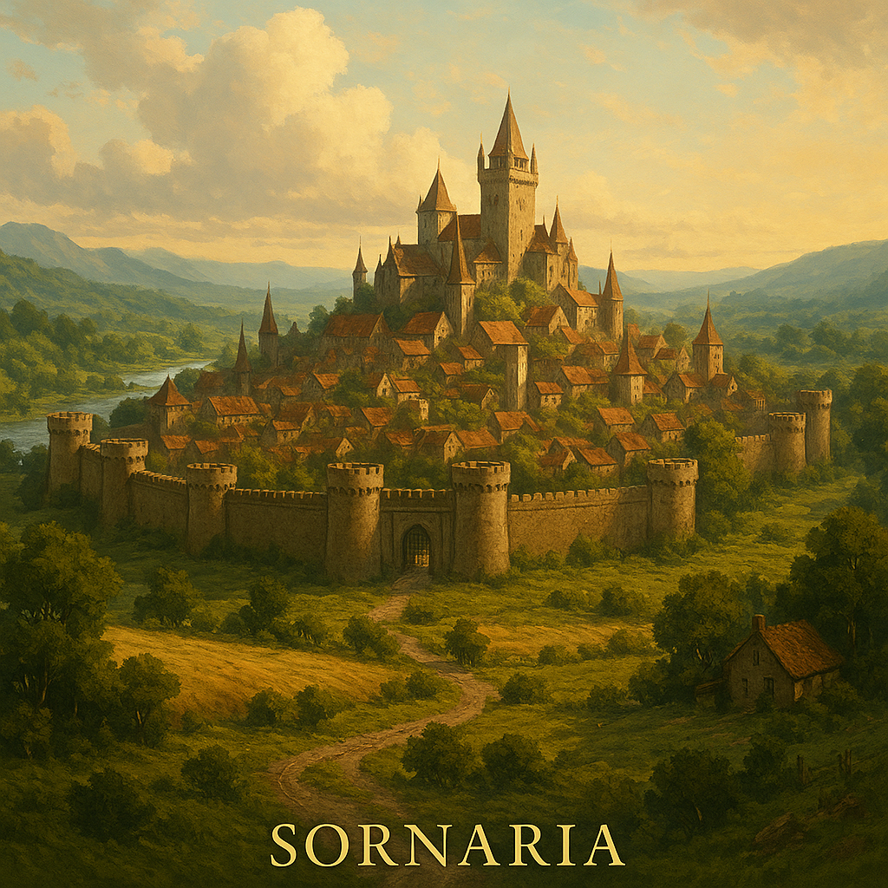

# Ironguard

## Description

A great dwarven stronghold kingdom built in and around a colossal mountain. Deep tunnels, elegant halls, and legendary forges define its terrain. A bastion of craftsmanship.

## Politics

Royal rule balanced by a council of elected guild leaders and nobles. Highly structured but modernized.

## Population

Primarily dwarves with occasional Dustborn, and humans.

## Main Exports

Coal, ores, forged goods, beer

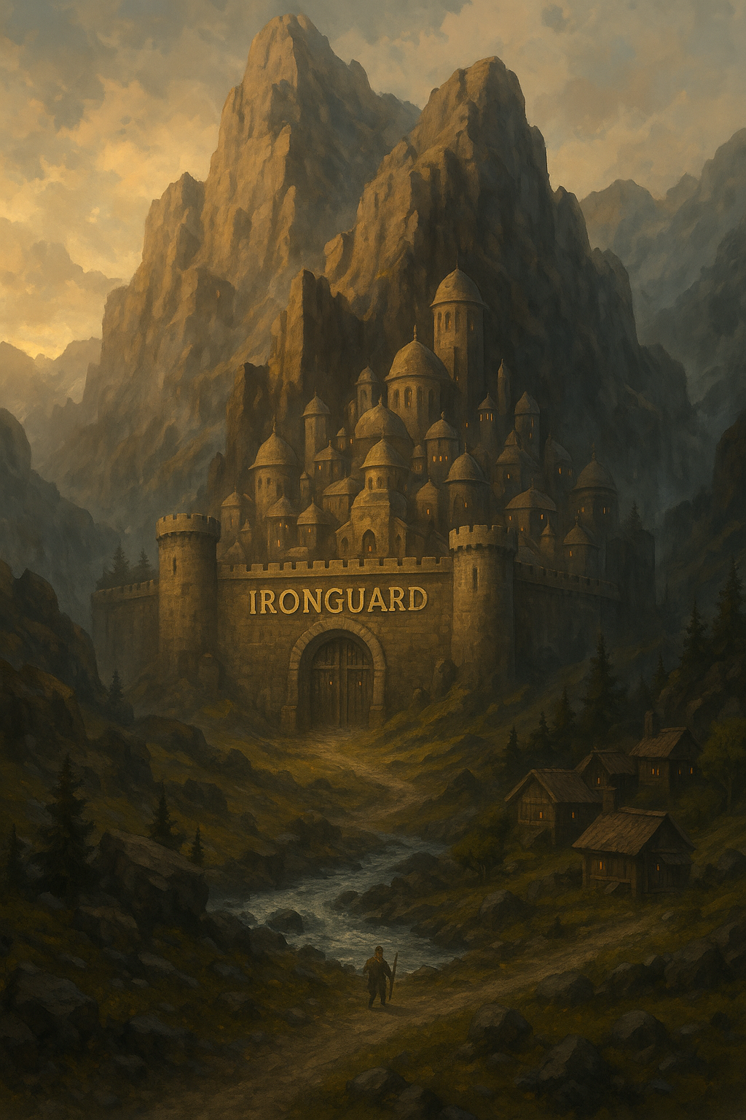

# Suzuka Islands

## Description

A floating sky island kingdom inhabited by Elves and Skyborn. Highly spiritual, elegant, and built with the philosophies and architecture of a high fantasy samurai era. Isolated, but self-sustaining and highly disciplined.

## Politics

Democracy by respect. Elders earn their position through proven wisdom and long service.

## Population

Skyborn and Elves, very few outsiders

## Main Exports

Arcane goods (leyline crystals), fine fabrics and clothing, ceremonial weapons (katanas), select literature and scrolls

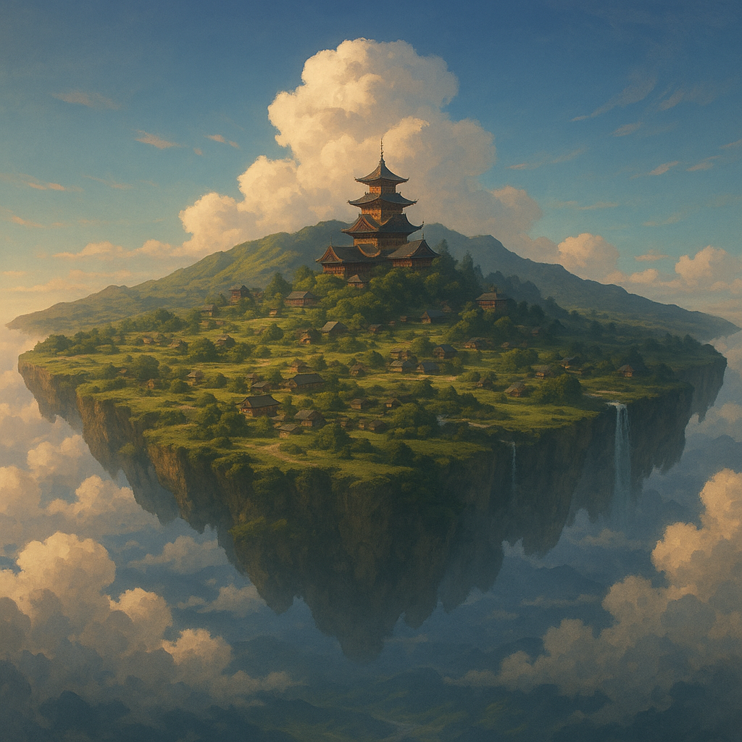

# Stonemold

## Description

A closed and oppressed dwarven kingdom buried deep beneath a mountain. Rumors speak of high taxes, corruption, and growing unrest beneath the surface.

## Politics

Tyrannical rule under a paranoid king, with citizens suffering under extreme inequality.

## Population

Mostly dwarves. Outsiders are rare and treated with suspicion. Elves especially unwelcome.

## Main Exports

Coal, gunpowder, copper, weaponry

## Narrative/Notes

Key plot arc: players must infiltrate and help lead a revolution from the inside, freeing the people and restoring balance.

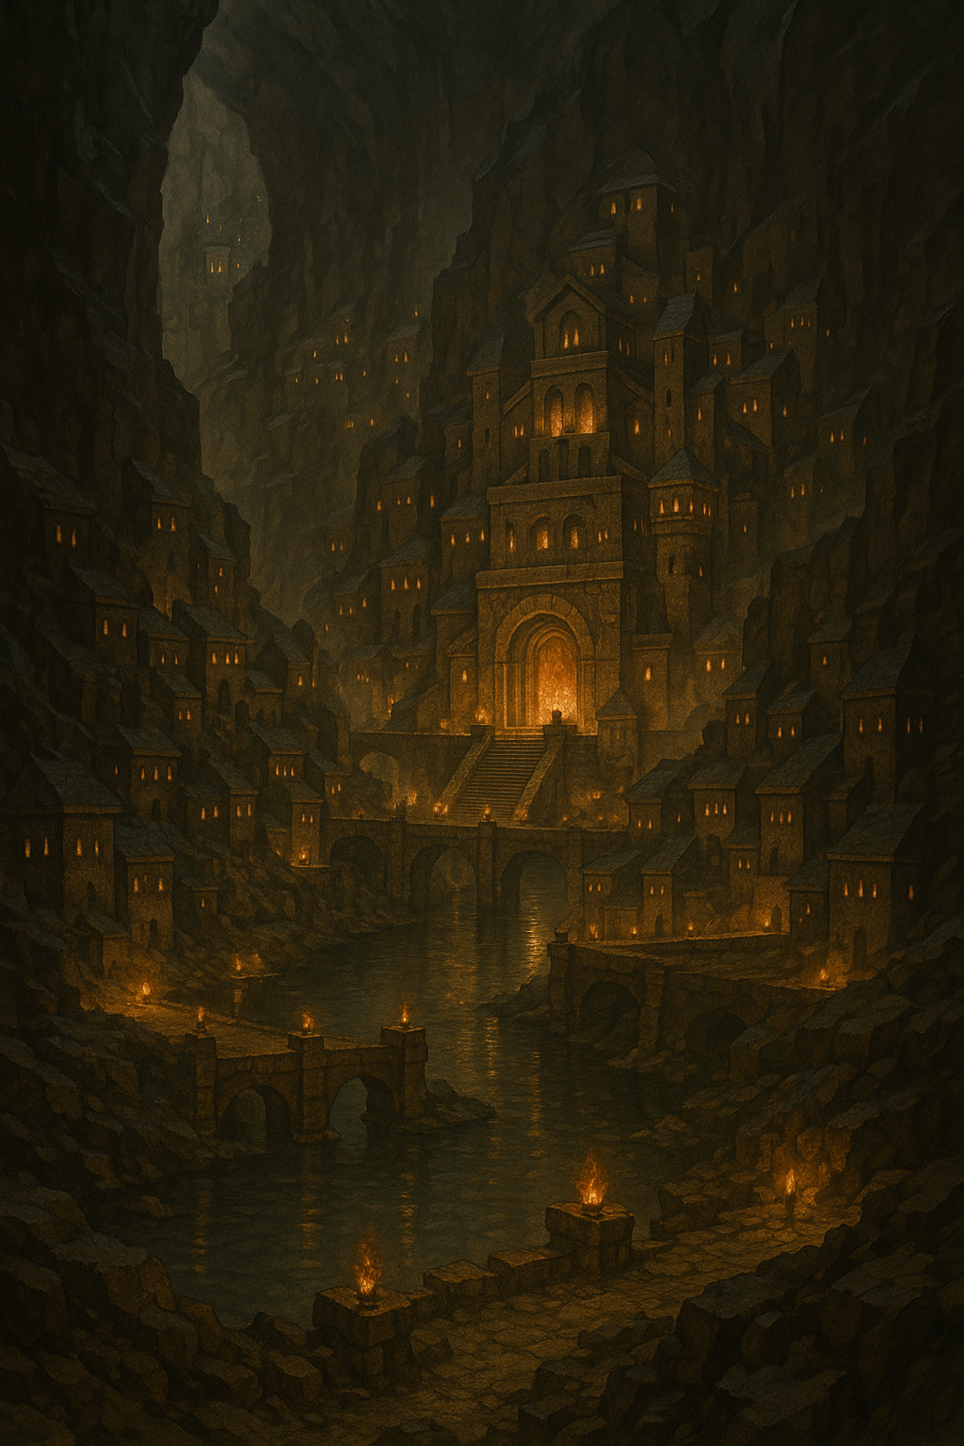

# Thipan Empire

## Description

A vast desert civilization rich with color, trade, and spiritual depth. The origin of the Dustborn and home to complex markets and ancient temples.

## Politics

Oligarchy ruled by a council of merchant-noble(kinda) families and religious figures.

## Population

Diverse population with a strong Dustborn presence.

## Main Exports

Spices, sandstone, dyes, livestock, textiles, jewelry, pottery

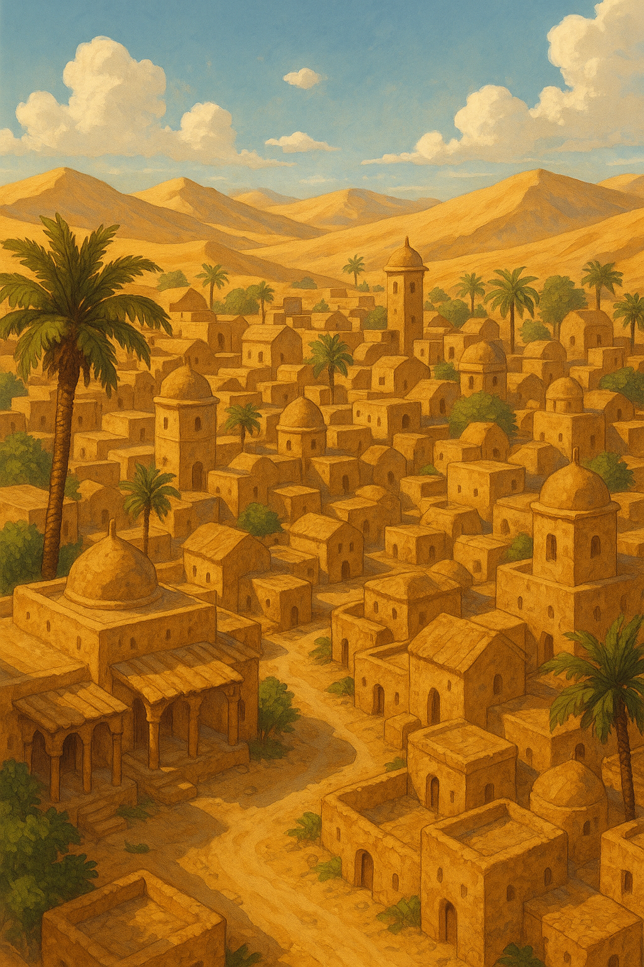

# The Jungle Empire

## Description

A lush, tree-dwelling kingdom with ancient ruins, vine-covered temples, and sprawling forest cities built into massive canopies. Culture is communal and spiritual.

## Politics

Unknown — may operate through tribal or elder council system.

## Population

Likely a mix of forest-adapted races: Elves, Aetherkin, and indigenous cultures.

## Main Exports

Textiles, fish, fruit, exotic meats, tree-based goods (resins, oils, herbs)

## Narrative/Notes

Visual aesthetics combine natural beauty and carved stone, inspired by but not directly copying Mayan civilization.

